JJMS – BAX

JJMS Hub Process

Business Narrative Ver 1.0

The below table is used to capture any issues that have to be addressed to enable solution design.

Point | Statement | Query / Action | Response
1

Approval by JJMS Representatives

“DC” Manager:
____________________
Signature / Date

____________________
Name

Approval by BAX Representatives

BAX Business Manager:
____________________
Signature / Date

____________________
Name

Table of Content

1. Goals 4
2. Organization Structure 5
3. BAX Implementation Team 6
4. General Information 7
5. Racking Layout and Location Numbering Schemes 8
6. Terminology 9
7. Abbreviations 10
8. Receiving 11
8.1. PO management process 12
8.2. ASN Process 12
8.3. Physical Receiving Process 12
8.4. Detailed Check Process 14
8.5. System Receiving Process 15
8.6. Receiving office process 15
9. Put-away process 16
10. Quality Control 17
11. Order Fulfillment 17
11.1. Normal Orders 17
11.2 Consignment transfers 18
11.3 Exchange orders (S5) 18
11.4 Manual Orders 18
11.5 Changes & Cancellations 18
11.6 Customer Service expectations 19
11.7 Packing 19
11.8 Shipping 20
12. Floater Management 20
12.1. SKU attributes 20
12.2. Inbound 20
12.3. Outbound 20
12.4. Return from Hospital 21
12.5. Replenish from Storage location to Floater bin 21
12.6. Reports 21
13. Inventory management 22
13.1. Material replenishment 22
13.2. Cycle Count 22
13.3. Material on “HOLD” 22
13.4. Adjustment 22
13.5. MRB 22
13.6. Scrap management 23
13.7. Shelf Life 23
13.8. Reports 23
13.9. Storer Information 24
13.10. Consignee Information 24
13.11. SKU set-up Information 24

Goals

The goals of the Operations Narrative are to:

- Summarize BAX Global requirements in the warehousing and distribution procedures to meet the business requirements, software and systems of Johnson & Johnson Medical Singapore DC (hereafter referred to as “DC”)

- Provide a blueprint for any custom code or modifications to the Exceed WMS System.

- Give BAX Global and “DC” business owners a good map of how the new system and processes will operate to meet the business requirements

Organization Structure

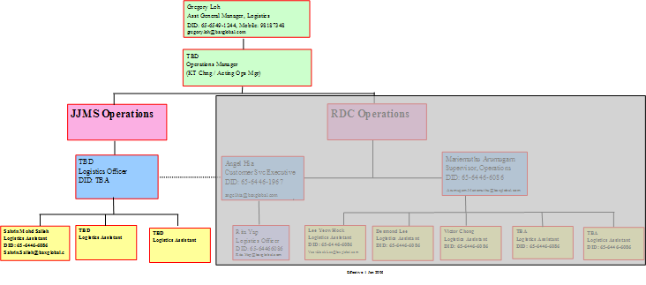

BAX Implementation Team

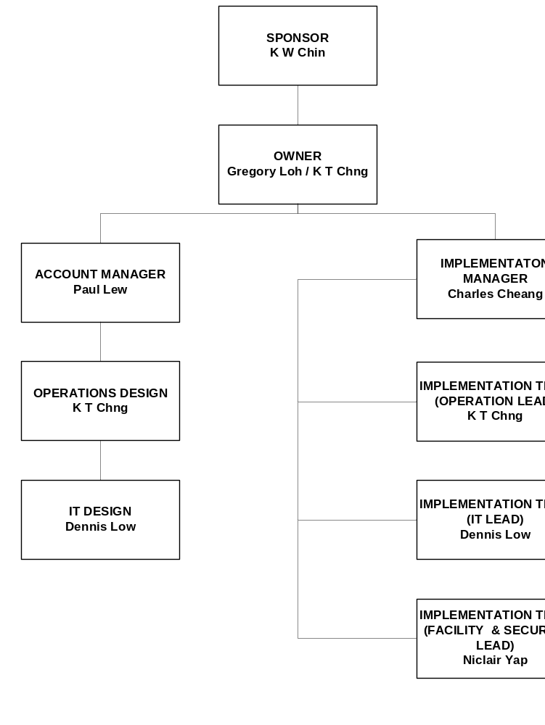

General Information

BAX Global will implement the BAX WMS to improve and enhance the present operations in the “DC” HUB warehouse. The BAX WMS is a warehousing and distribution management system that is designed to manage the tracking of goods as they move in, around and out of the “DC” Hub. The Exceed WMS is an auditable application, maintaining all records of receipts, moves, adjustments and withdrawals.

The functions BAX will perform for DC will be:

- Inbound
- Inbound Inventory Reporting
- Receipt / receiving of goods for

Material from supply source
- Returns from hospital and clinics

- Inventory Management
- Cycle counts
- Stock movements
- Putaway / storage
- Reporting
- Damaged material

- Order Fulfillment
- Order Capture
- Manual order allocation for
- Marketing & Loan
- Tools (Depuy)
- Automatic Order Allocation
- Order shipment
- Documentation

Racking Layout and Location Numbering Schemes

The Facility will use shelving and bulk floor storage locations for storage of “DC” material. The layout will be configured to best suit space optimization and operational efficiency.


Aisle Location Level Position

Barcode labels will be used for all locations, they will be identified by aisle, bay, level and position. They will be human readable with a barcode reflecting the number that can be utilized via for putaway and picking.

06-22-D1

*0622D1*

Terminology

BAX | “DC”
SKU | Customer Code
Manufacture SKU
Storer
ASN (856)
Receipt
Putaway
Quality Control (QC)
Shipment Order (940) | Dispatch
Picking
Returns
Purchase Order (850)
Cycle Count
Physical Stock Take
(Issue Log: JJMS to provide the equivalent to BAX’s terminology)

Abbreviations

Abbreviation | Term
SKU | Stock Keeping Unit
ASN | Advanced Shipping Notice
ITS | Inbound Tally Sheet
PRN | Pre-receipt Notification
VL# | Vendor Lot Number
WMS | Warehouse Management System
QC | Quality Control
856 | Advanced Shipping Notice Message
861 | Receipt Confirmation Message
940 | Shipment Order Message
945 | Shipment Confirmation Message
852 | Inventory Reconciliation Message
PO | Purchase Order
DO | Delivery Order
CC | Cycle Count
LP | License Plate
DN# | Delivery Notice Number
POI | Payment On Issue
COI | DC Owned Inventory
LOI | Letter of Intent
RMA | Return Material Authorization
UAI | Use As Is
CS | Customer Service

Receiving


Initial Receipt (Material Unloading)

- BAX will perform the initial check of the merchandise, recording any nonconformance and sign on the transport documentation.

Detailed Check

- BAX will perform a detailed check matching the system to the physical to delivery documents. BAX will not open any carton to verify contents. A pallet or carton ID will be applied to every pallet or part there of.

PO management process

    - NO PO message will be received

ASN Process

    - DC receives expected inbound information from JJMS via email
      - consist of Supplier Invoice and delivery information

    - DC creates ASN in the WMS system [phase 1, manual operations]
      - phase 2, DC performs receipt in JDE
      - JDE exports file to FTP
      - DC uploads file from FTP into WMS
      - File uploaded auto creates the WMS ASN

        - If file upload fail, check WMS for
- Unknown SKU
- Incomplete / incorrect data fields

    - If Shipment arrived without ASN / supplier documents
      - check for PO number on inbound document
      - confirm if PO number and PO contents are valid in JDE
        - if PO valid in JDE, create manual ASN in WMS [phase 1]
        - if PO valid in JDE, perform JDE receipt [phase 2]
        - if PO invalid in JDE, contact JJMS CS
        - if PO valid but contents incorrect, contact JJMS CS

    - Material returns from hospitals
      - Collection Note is printed from JDE
      - DC arrange collection from hospitals
      - DC creates ASN using JDE Collection Note number as the ASN reference

Physical Receiving Process

    - Material is unloaded from truck

    - Perform initial receiving check,
- Total quantity
- Physical condition [Quality Control specifications from JJMS]

    - Sign delivery documentation
      - If a discrepancy is noted [short, excess, damaged] sign delivery documentation to reflect discrepancy
      - ASN must create according to document expected qty [phase 1]
        - phase 2, full GIT receipt must be done in JDE to export file for WMS ASN creation
      - manage the discrepancies via exceptions process

    - Place material in detailed check area

Point | Statement | Query / Action | Response
1 | Non inventory items (CapEx); these items are immediately expensed off in JDE upon receipt | How to manage in WMS | BAX to receive into WMS; SKU with NI identifier; provide NI report to JJMS on a weekly basis

Detailed Check Process

- Verify information on ITS against part number and quantity stated on the Item

    - Perform detailed check
      - Remove items from packing cartons, check
- SKU
- Quantity
- Lot number [same lot will have same UBD]
- Use by Date

      - For short receipt,
- ASN should be created according to document expected qty
- receive according to physical counted qty
- file a discrepancy report to JJMS CS

      - For incorrect SKU,
- inform JJMS CS and await disposition
- place material in a physical Hold location

      - For over receipt
- Receive into both systems according to doc qty
- Inform JJMS of the excess qty
- JJMS create a new line in JDE and inform BAX to receive in
- BAX create a new ASN line to receive in the excess qty

      - For damage,
- Take picture of damaged item
- File discrepancy report and email to JJMS for disposition
- Receive material into WMS and JDE
- Place material in a physical Hold location
- Move materials into WMS Hold location
- Once disposition available from JJMS, move item to “Damaged Loc”
- JJMS to write-off item in JDE

    - Results are recorded onto the ITS
    - Apply LP on each moveable unit if all items are of same
- sku
- Lot
- Use by date
    - record Use by date on the ITS
    - record Lot number on the ITS
    - When check is completed ITS is taken to receiving office

System Receiving Process

    - WMS receipt, retrieve ASN
- scan SKU from ITS
- input Quantity received
- input Lot number
- input Use by date
- scan LP from ITS

    - JDE receipt
      - phase 1, perform JDE receipt against PO
      - phase 2, perform JDE receipt from GIT location

Receiving office process

    - Check all material has been received into WMS system
      - If incomplete verify with checker

    - Run the ASN receiving check report to verify all receipts are correct.
      - If any errors, send Email to JJMS

Put-away process

    - Scan LP with RF

    - Take material to available location

    - Scan location label
[WMS will now reflect new location]

    - Repeat process until all material is putaway

Quality Control

At time of receiving, perform visual check to ensure all DC materials are free from visual damage

physically segregate materials identified as damaged

perform system Hold on such materials

Damage consist of
- water mark
- blood stains
- crushed
- quality seals broken

For returns from Hospitals
- Driver to feedback the above at point of collection
- JJMS to send representative to hospitals to assess items

Order Fulfillment

Normal Orders

BAX will generate pick slip in JDE at the following times
- 10am
- 4pm
(BAX may choose to generate pick slip before the above cut-off time to pick order in advance)

Pick Slip contains:
- SKU / Product ID
- Qty
- ShipTo customer
- Bill to party name
- Customer Purchase Order No. (not mandatory)
- Remarks
- Sales order number

BAX creates WMS shipment order

using Pick Slip information [phase 1]

using JDE file export to upload into WMS [phase 2]

BAX generates the WMS Pick List

Allocation Logic:
- FEFO then FIFO

BAX performs picking

BAX generates WMS Packing list

BAX performs ship confirm in JDE for actual picked qty

- Invoice is auto generated in JDE

BAX prints invoice & delivery note from JDE

3 DN

2 Invoice

BAX consolidate delivery documents and goods according to shipto destination

BAX contacts transporter

Transporter pick up

BAX ship wave from WMS

BAX collect proof of delivery from transporter

BAX collects proof of delivery from transporter

1 copy of signed invoice or signed DN if invoice not available

1 copy of delivery note

consolidate and arrange return to JJMS once a month

BAX photocopy 1 set for file

11.2 Consignment transfers
11.2.1 pick slip indicating “bill and replace”
11.2.2 run consignment charge from JDE
11.2.3 attach invoice printed from consignment charge to the corresponding delivery note and product (to be delivered to customer)
11.2.4 for consignment transfers without consignment charge, just attach the printed delivery note to product for delivery to customer

11.3 Exchange orders (S5)
11.3.1 for S5 type orders, proceed to print Collection Note
11.3.2 upon receipt of materials, refer to Inbound Process

11.4 Manual Orders
11.4.1 when JDE is down, orders will be faxed to BAX DC
11.4.2 refer outbound process
11.4.3 ship to customer using temporary receipt
11.4.4 customer acknowledge on temp receipt
11.4.5 BAX to print and deliver actual invoice to customer for acknowledgement when JDE is functional

11.5 Changes & Cancellations
11.5.1 If status of order is shipped, JDE will issue a Credit note to return item back to stock; BAX will ship out the order and create an ASN to receive item in
11.5.2 If status of order is not shipped, JDE will reverse the Order; BAX to reverse WMS order & return materials to bin location

Point | Statement | Query / Action | Response
1 | Customer master | Need to upload JDE customer master into WMS | JJMS to provide
2 | Type of orders | What are the different types of orders in JDE | Sales (SO)  Scheduled (SA)  Int’l Sales (SI)  Exchange (S5)  Samples (SP)  Free goods (FG?)  Warranty (SL)  Donation (SF)  Consign trf (ST)  Pre-shpt (SH)
3 | Invoice | When is an invoice required | Applies only to  SO  SI  SA  SG – consign charge
4 | Delivery pick up times | frequency | 8.00am  12.30pm
5 | Manual delivery note | When is this applicable | When system down after month close; affected 1-2 days
6 | Electronic filing of POD | How to use system to manage POD more effectively | BAX to review how this can be done
7 | Barcode format for each franchise | Is the format same | JJMS to provide

11.6 Customer Service expectations
- order cut off time for each day (10am & 4pm; pick slip can be printed at any time between these hours).
- Orders before 10 a.m., customer service will indicate ship current day for 12.30pm pick up & delivered same day
- non urgent orders received before 10am and normal orders received before 4pm will be delivered next morning 8am
- BAX to provide daily summary of
- Invoices/delivery note printed and delivered to customer
- Invoices/delivery note collected back with customer acknowledgement

11.7 Packing

11.7.1 Move materials to Packing Stage area

11.7.2 Scan Sales order #

11.7.3 Assign / scan package ID

11.7.4 Scan carton ID to package ID (Shipper Carton).

11.7.5 Pack carton

11.7.6 Close package when complete

11.7.7 Print packing list and apply to carton

11.8 Shipping

    - WMS is checked to verify all picks are complete
    - Contact trucking company for package pick-up
    - Handover package with
- 2 copies of Summary Packing Note
- 1 copy of Invoice
    - Trucking company sign on 3rd copy of Summary Packing Note and return to DC for filing
    - Trucking company delivers package and handover to customer
- 1 copy of Summary Packing Note
- 1 copy of Invoice
    - Customer sign on 2nd copy of the Summary Packing Note and return to trucking company
    - Trucking company return the signed copy of Summary Packing Note to DC on the following day for filing

Floater Management

SKU attributes
12.1.1 Cordis [Cypher] - all Sku with prefix “CR”
12.1.2 Depuy - JJMS to provide Bill of Material list for each Floater set
12.1.3 WMS maintains this identifier

Inbound

    - refer Inbound process
    - ITS to show Float identifier
- Cordis: Store will putaway item to FLOAT bin
- Depuy: Store will putaway item to normal bin loc

Outbound
    - during office hours, JJMS instruct warehouse via email, follow up with phone call
    - after office hours, JJMS instruct warehouse via phone call, follow up with email by next working day
    - the following information required
- shipto location
- shipto party name
- product set name
- Time
- time of case
    - BAX create Floater order from WMS Hub Float Module
    - Dispatch Job in hub Floater module
- items will be moved from FLOAT location to HOSP loc
- Floater Dispatch Note will be printed
- Warehouse check items using Floater Dispatch Note
    - Arrange transporter to collect
    - release Floater with Floater Dispatch Note
    - return a copy of the Floater Dispatch Note to JJMS monthly via courier

Return from Hospital

    - Cordis: JJMS will instruct warehouse via email, followed by phone call to collect from hospitals
    - Depuy: BAX to arrange collection 24hours after time of case [applies to working days only, unless otherwise instructed by JJMS]
    - Depuy [for SGH only]: JJMS will instruct warehouse date and time of collection via email, followed by phone call
    - Count balance items in Floater using the Floater Dispatch Note
    - Record quantity returned
    - Update Hub Floater order with qty returned for each SKU
    - Finalize hub Floater order
- For qty consumed, a WMS order will be auto created and shipped
- For returned qty, auto move back to FLOAT location
12.4.8 Putaway Floater bin to Floater staging area
12.4.9 JJMS will create JDE order
12.4.10 BAX will create JDE pick slip
- remarks will indicate “Bill only” for consumed qty
- remarks will indicate “Bill and replace” for qty consumed due to replacement of consign stocks at hospitals
12.4.11 BAX perform Ship Confirm in JDE for the consumed qty
12.4.12 Print JDE invoice for the consumed qty
12.4.13 Deliver Invoice to hospital

Replenish from Storage location to Floater bin

12.5.1 Cordis: BAX to provide JJMS with Floater inventory list daily
12.5.2 Depuy: Hub Floater Module to auto generate a replenishment order for the consumed qty
12.5.3 perform stock transfer from storage to Floater bin
12.5.4 print stock transfer report for picking
12.5.5 pick items from storage and place into Floater bin

Reports

    - Cordis: BAX to provide JJMS with Floater inventory list daily
12.6.2 Depuy: daily Floater inventory status (by location)

Inventory management

Material replenishment
    - J&J will provide BAX with minimum stock levels for all materials stored in the BAX DC
13.1.2 when inventory onhand fall below the pre-defined minimum level, an alert will be sent to JJMS via email upon occurrence

BAX will develop a “Stock Alert Report” detail
- MIN qty (safety stock level)
- Storer (option to activate this requirement by storer)
- SKU
- SKU group (JJMS to provide JDE classification; option to activate this requirement by SKU Group)
- Available qty (alert trigger)
- Qty Allocated
- Qty Picked
- QTY on hold
From this report, J&J will determine the replenishment requirement.

Cycle Count
13.2.1 BAX will perform 1 cycle every 3 months (JJMS to revert)

Material on “HOLD”
13.3.1 JJMS will advise BAX of material to be held via email, information supplied will be:
- SKU
- LOT #
    - BAX will place a system hold and move the material to a quarantine location
    - A material ‘On Hold’ report will be provided to JJMS

Adjustment

- Any adjustments to the JDE inventory and the associated reason code will be recorded and reported to “DC”.
- Any physical shortages & excess will be adjusted in WMS and an adjustment report filed to JJMS

MRB

- BAX will receive returned material from hospitals and clinics (refer to section 8.2)
- Refer to QC process and report to JJMS on any discrepancy

Scrap management

    - BAX provide list of expired items
    - JJMS will advise items to be scrapped [monthly]
    - JJMS will write off items in JDE [monthly]
    - BAX pick and move items to SCRAP location
    - Move WMS to SCRAP location
    - JJMS will inform BAX of physical scrap exercise date
    - BAX create WMS order with scrap reference number
    - BAX performs picking at SCRAP location
    - BAX will arrange for scrap vendor
    - Performs scrap exercise [JJMS to witness]
    - Ship wave from WMS
    - Provide scrap certificate to JJMS

Shelf Life

    - Minimum shelf life days by product [JJMS to revert]
    - For outbound, as long as product is still within the Use by date, proceed to ship
    - Send Aging report to JJMS [days shelf life remaining]

Reports

BAX Internal

Name | Frequency | Time | Type | Comments
ASN | Per activity
ITS | Per activity
Pick List | Per activity

JJMS

Name | Frequency | Time | Type | Comments
Daily Receiving Report | Daily |  | WMS | Summary of daily receiving
Daily Shipment Report | Daily |  | WMS | Summary of daily shipment
Inbound Discrepancy Report | Per activity |  | Manual | Report to J&J on items received damaged (to attach photo)
Inventory Alert Report | Daily |  | WMS | Report to J&J on inventory (by SKU) which fall below pre-determined MIN. level
Inventory Aging Exception Report | Daily |  | WMS | To provide a list of inventory with less than 12 month remaining shelve-life
Non-Inventory List | Weekly |  | Manual | For Tools and capital items

Storer Information
(DC to revert to BAX in excel via e-mail)
- Vendor code/Storerkey (JDE branch plant)
- Company name
- Address
- Contact person
- Phone
- Fax
- E-mail

Consignee Information

Update will be via email on a as required basis
- ShipTo Address (Ship to Code)
- Bill to Address (bill to Code)

SKU set-up Information
(refer Workshop Comm Log)
Frequency to be advised (JJMS)
- SKU (DC part #) for A / B parts, the ODM’s part number is to be recorded into the ‘Alternate SKU ‘ field)
- Description
- ODM's part #
- Vendor's part #
- Net Weight
- Supplier Part no
- Commodity Type
- New Product / Normal / Phased out Flag
- Sub table for Country allocation and Qty
- Location Regulatory Flag vs Country allocation vs Country of Origin (sub table)
- Box Qty
- SKU attribute Flag [NI, FLOAT]
- Min Stock Level
- SKU Group [for the purpose of selective stock alert triggers]

